**Waterfall Methodology**

1. Core Concepts of the Waterfall Methodology
2. Phases of the Waterfall Model
3. Characteristics of the Waterfall Model
4. Advantages of the Waterfall Methodology
5. Disadvantages of the Waterfall Methodology
6. Real-World Example of Waterfall
7. When to Use Waterfall Methodology

The **Waterfall methodology** is a traditional project management approach that follows a linear and sequential design process. Originally developed for software development, it has been widely used across various industries. The methodology is named "Waterfall" because its phases cascade downwards like a waterfall, with each phase needing to be completed before the next one begins.

**1. Core Concepts of the Waterfall Methodology**

1. **Linear Process:** Waterfall follows a strictly linear path. Each phase must be completed in its entirety before moving on to the next.
2. **Documentation:** Waterfall emphasizes comprehensive documentation at every stage, ensuring that each phase’s requirements, processes, and outcomes are well-documented.
3. **Early Planning:** All project requirements are gathered and agreed upon at the start, making the planning phase crucial to the success of the project.
4. **Fixed Phases:** The project is divided into distinct phases, each with specific deliverables and review processes.

**2. Phases of the Waterfall Model**

The Waterfall methodology typically involves the following phases:

**2.1 Requirements Gathering and Analysis**

* **Purpose:** To collect all project requirements from the stakeholders and document them thoroughly.
* **Activities:**
  + Conducting meetings with stakeholders to understand their needs.
  + Creating a detailed requirements document that outlines every aspect of the project.
* **Outcome:** A finalized requirements specification document, which serves as a blueprint for the entire project.

**2.2 System Design**

* **Purpose:** To design the architecture and components of the system based on the requirements document.
* **Activities:**
  + Designing system architecture, databases, and user interfaces.
  + Preparing technical specifications and diagrams.
* **Outcome:** A comprehensive system design document that guides the development phase.

**2.3 Implementation (Coding)**

* **Purpose:** To convert the system design into a functional system through coding.
* **Activities:**
  + Developers write code based on the design specifications.
  + Code is typically implemented in modules or units.
* **Outcome:** A working product or system, completed in accordance with the design specifications.

**2.4 Integration and Testing**

* **Purpose:** To combine all modules and test the system as a whole to ensure it meets the specified requirements.
* **Activities:**
  + Integrating all individual modules into a complete system.
  + Conducting various types of testing (unit, integration, system, user acceptance).
* **Outcome:** A validated system that is ready for deployment.

**2.5 Deployment**

* **Purpose:** To deploy the system in a live environment where end-users can begin using it.
* **Activities:**
  + Installing the system in the production environment.
  + Providing user training and support.
* **Outcome:** The system is live and operational.

**2.6 Maintenance**

* **Purpose:** To manage any issues or enhancements after the system has been deployed.
* **Activities:**
  + Fixing bugs or errors reported by users.
  + Implementing updates or improvements as needed.
* **Outcome:** A stable and maintained system that continues to meet user needs.

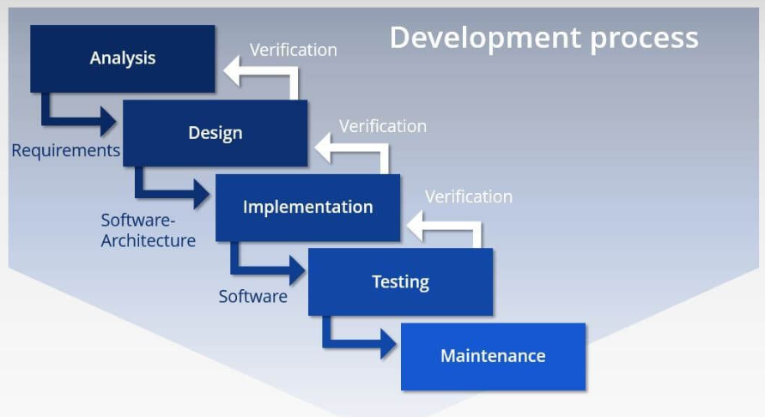

**3. Characteristics of the Waterfall Model**

1. **Sequential Phases:** Each phase must be completed before the next begins. There is no overlap between phases.
2. **Rigid Structure:** Once a phase is completed, going back to make changes is difficult and costly.
3. **Heavy Documentation:** Every phase produces detailed documentation that is used in subsequent phases.



1. **Emphasis on Initial Planning:** The success of the project heavily depends on accurate and complete requirement gathering and planning.



**4. Advantages of the Waterfall Methodology**

1. **Simple and Easy to Use:** The linear and structured nature makes it easy to understand and manage.
2. **Clear Milestones:** The end of each phase provides a clear milestone, making it easier to track progress.
3. **Comprehensive Documentation:** Detailed documentation ensures that all stakeholders are aligned and that the project can be handed over easily.
4. **Well-Suited for Smaller Projects:** Works well for smaller projects with well-defined requirements that are unlikely to change.

**5. Disadvantages of the Waterfall Methodology**

1. **Inflexibility:** Changes in requirements are difficult to accommodate once the project is in the later stages.
2. **Late Testing:** Testing occurs only after the implementation phase, which may lead to higher costs for fixing defects found late in the process.
3. **High Risk:** If there are any errors in the requirements gathering or design phase, they might not be discovered until much later, increasing the risk of project failure.
4. **Customer Involvement:** Minimal customer interaction after the requirements phase, leading to potential misalignment between the final product and customer expectations.

**6. Real-World Example of Waterfall**

**Example: Construction of a Building**

* **Requirements Gathering:** Architects and engineers gather all the requirements from the client, including the size, purpose, and design of the building.
* **Design:** Detailed blueprints and structural designs are created.
* **Implementation:** The construction team builds the structure according to the blueprints.
* **Testing:** Inspections are conducted to ensure the building meets all safety codes and specifications.
* **Deployment:** The building is handed over to the client for use.
* **Maintenance:** Regular maintenance is conducted to ensure the building remains in good condition.



**Example: Building a Hospital Management System**

* **Requirements Gathering:** Collecting detailed specifications from healthcare providers for patient management, billing, and reporting systems.
* **System Design:** Creating architectural and detailed design documents that map out the software’s structure.
* **Implementation:** Developers write the code for each module (e.g., patient records, billing, appointments).
* **Integration and Testing:** The modules are integrated into a cohesive system and tested for accuracy and performance.
* **Deployment:** The system is installed in the hospital and staff is trained.
* **Maintenance:** Addressing any issues or updates as they arise post-deployment.

**7. When to Use Waterfall Methodology**

Waterfall is best used in scenarios where:

* Requirements are well-understood and unlikely to change.
* The project is simple and well-defined.
* A sequential approach is necessary due to the nature of the work (e.g., construction, manufacturing).
* High levels of documentation are required.